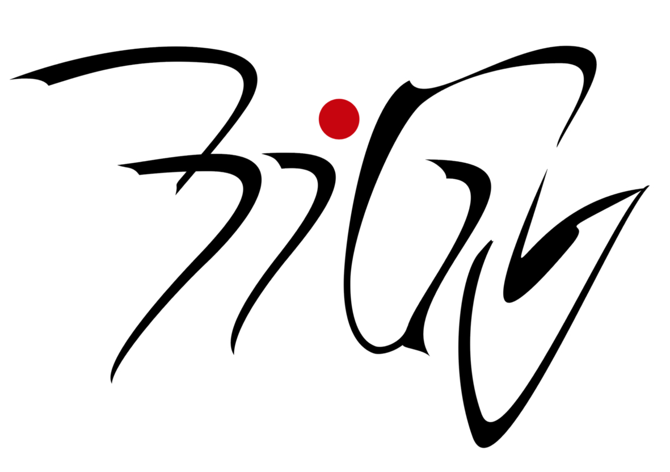 Project Day 8. 11. 2017
________________________________________________________________

English Class Project Day 2017

Title: Cross-cultural Contact

Would you like to meet students from different countries studying in HK?

Aim: learning more about different countries, giving presentations about our school, HK, CR

Contents: helping foreign students with Czech language ( explanation in English…), presentations, communication, games for getting to know each other

Output: PowerPoint presentations

Target Group: all levels

Max students: 20

Requirements: a flash drive

Meeting point: school at 8.00

Guarantor: Mgr. Vránová

